

**University of Edinburgh**

**School of Geosciences**

Evaluating Forest cover change in red panda (*Ailurus Fulgens*) habitat from 2000 – 2018

*By*

Cameron Cosgrove

In partial fulfilment of the requirement for the

Degree of BSc with Honours in Ecological and Environmental Science

April 2019

# Abstract

Habitat loss has consistently been identified as the largest threat facing the endangered red panda. Low dispersal capabilities, arboreal lifestyle, and narrow distribution also make red pandas particularly susceptible to reproductive isolation cause by habitat fragmentation. For the first time, this dissertation quantifies the extent of forest loss across the red pandas entire range, and maps the areas of low and high habitat disturbance. My results show that 1.3% of forest habitat has been lost since 2000 - 2018. The XXX area and the YYY area show the most pronounced forest loss. No countries show a net increase in forest from 2000 - 2012 in red panda habitat. Protected areas have loss less forest than non protected areas. Habitats at lower elevation show the highest amount of habitat loss, which correlates with higher human population. The forest network in red panda habitat is likely fragmented into 3 isolated populations, with X habitat bottlenecks experiencing moderate to high disturbance. The conservation implications of this work are…

Table of Contents

Abstract 2

Table of Contents 3

Acknowledgements 5

List of abbreviations 6

1. Introduction 7

The red panda 7

Ecology 7

Red panda conservaiton 9

1.3 Project Rationale 9

A remote sensing approach 10

1.4 Research questions and hypotheses 10

What change has occurred to forests in red panda habitat? 11

Where has forest been lost in red panda habitat? 11

2. Methods 11

2.1 Defining the study area 12

2.2 Data collection 12

Global Forest Change Dataset 12

Red Panda distrubution 12

2.3 Data processing 12

Forest Change 12

Hot spot identification 12

2.4 Data analysis 12

3. Results 12

3.1 What change has occurred to forests in red panda habitat? 13

3.2 Where has forest been lost in red panda habitat? 14

14

4. Discussion (Demonstrate Understanding!) 15

Key findings 15

4.1 How is Red Panda Habitat changing? 15

4.2 Conservation implications 15

4.3 Limitations 15

What needs to be considered when interpreting my results? 15

4.4 Future work 15

5. Conclusion 16

6. References 16

7. Appendices 16

Acknowledgements

Izzy Rich is my hero ☺

List of abbreviations

GEE – The google earth engine

MaxEnt – Maximum entropy distribution model

IUCN

CITIES

GFC – Global forest change dataset

RQ1

RQ2

1. Introduction

Terrestrial mammal populations are changing rapidly around the world. Human activity such as hunting and ecosystem modification are driving these changes. SOME DATA FROM A STUDY WOULD BE NICE HERE. This is of concern for a number of ethical, practical, and aesthetic reasons. Much attention is given to reversing these changes and finding evidence based solutions for mammal conservation, particularly for preventing species extinction. Data is needed to make informed conservation decisions, but is often unavailable due to the remoteness or large size of field sites. Remote sensing tools such as satellite imagery are increasing being used to measure and monitor relevant ecosystem variables can greatly enhance mammal conservation efforts.

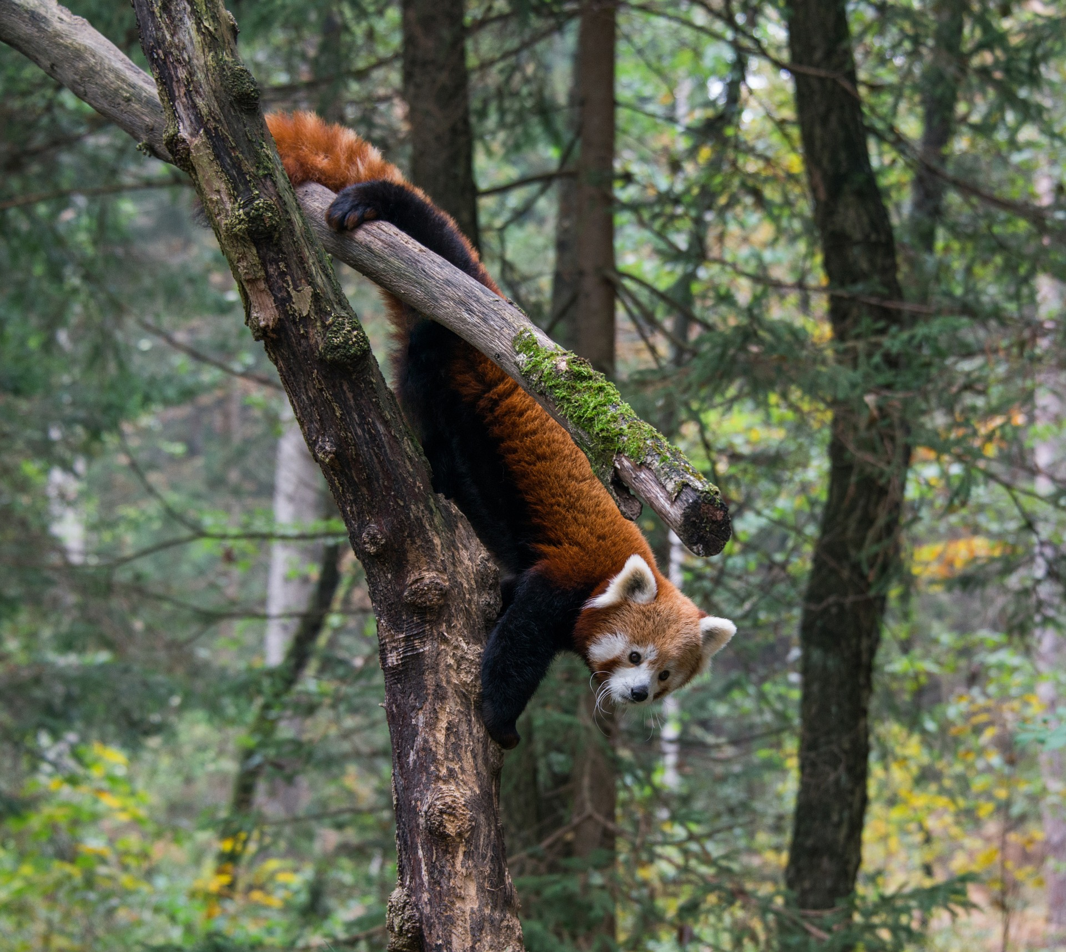Expanding human populations are encroaching into a range of habitats, increasing the magnitude of ecosystem modification. Land use change and habitat fragmentation have the largest impact on mammal populations, causing a greater inpact globally than hunting. Arboreal mammals with narrowly defined niches and low dispersal capabilities, such as the red panda, are the most susceptible to population declines following habitat disturbance. Quantifying and mapping habitat changes is key for informing conservation efforts for these sensitive species. The remote Himalayan range of the red panda makes remote sensing the most viable option for evaluating large scale habitat change caused by the increasing human population within panda habitat.

Figure 1: A

The red panda

The red panda (*alirus fulgens*) is an endangered mammal found between 1000, and 5000 m in hillside forests with bamboo understory. Red pandas are exacting in their habitat requirements and prefer undisturbed habitats with over 30% forest and bamboo cover. Red pandas are omnivores but subsist almost exclusively on bamboo 98% of their diet being from bamboo. Red pandas are predominantly solitary and exist at low densities (1 panda per 4km2). The red panda composes its own unique tanxnomix family. Two genetically distinct populations of red pandas exist, separated by the Nujiang river valley. Whether these two populations represent two distinct species is still an area of active research. Even tho

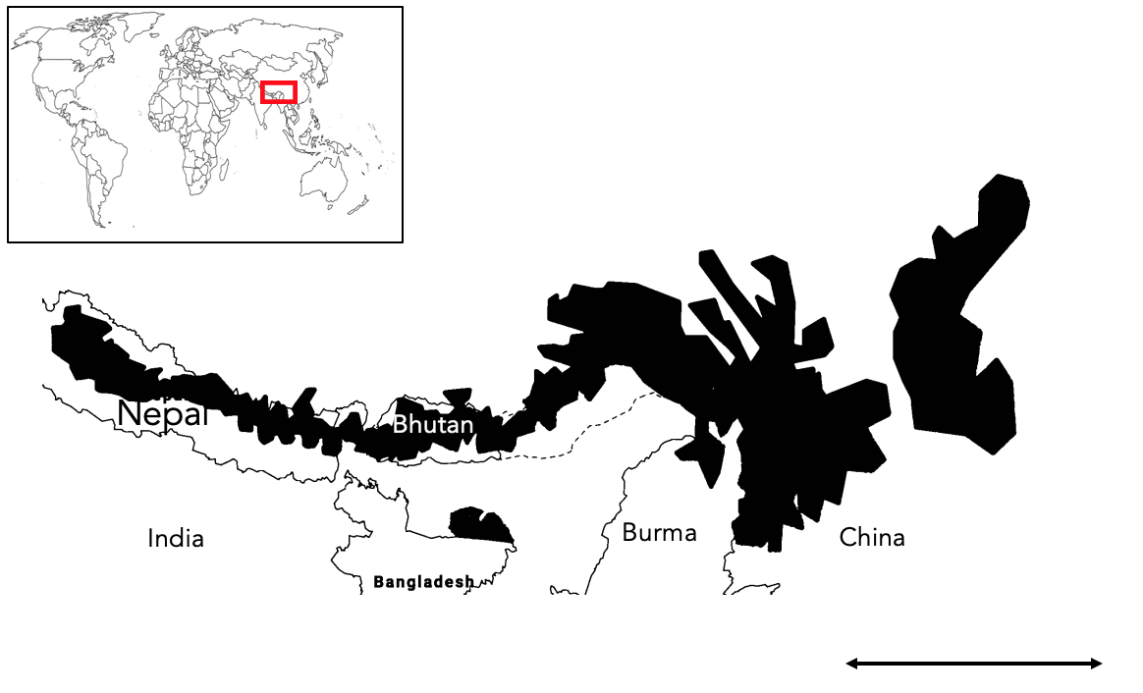

This once obscure mammal is now receiving more public attention, yet conservation efforts for the species lag significantly behind the more famous Giant Panda and other high-altitude species such as the Himalayan musk deer (Moschus leucogaster), with many aspects of red panda ecology and distribution still unknown. The population of red pandas is feared to have declined by 50% over the last three generations, raising concerns about the species extinction. Precise population trends are unknown due the sparse number of red panda records across its range. Red Pandas are most well documented in Nepal and Sichuan China, yet even here most information comes from indirect signs such as scat and pug marks. Where populations are studies, they are found in clustered pockets of habitat away from human disturbance and close to water and bamboo thickets.

Low density and mainly solitary/ Fecundity/ movement patterns? Three known isolated populations. Diet

Economic opportunities for people in Red panda habitat are limited and are often based around harvesting natural resources, which tends to damage panda habitat. Small scale timber harvesting for firewood and building, and clearing for agriculture and grazing are the dominant mechanism for forest loss in panda habitat.

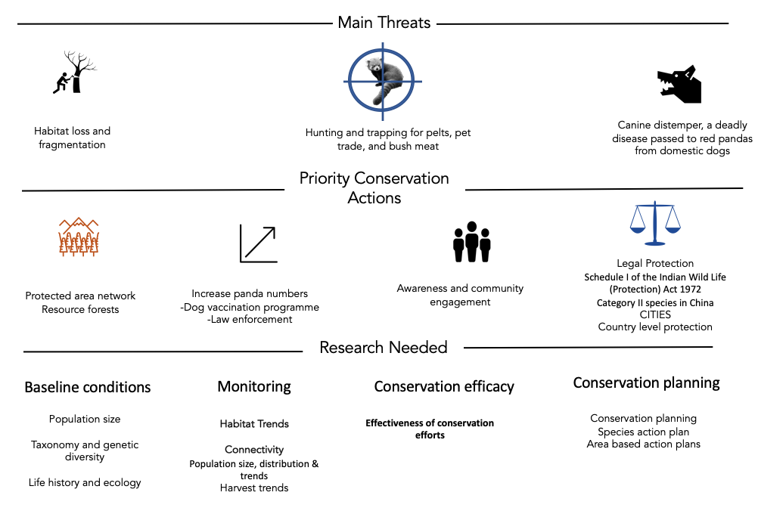Local action. Wide scale measures are not red panda specific. No coordinated range wide management plan exists. I have found it suspiring that there is not more research and conservation interest for the red panda, considering it is cute af. The species primarily suffers from lack of research due to remote distribution, however much of its habitat is now accessible.

Habitat loss is consistently stated in the literature as the largest threat facing red pandas.

1.3 Project Rationale

A range wide conservation plan is needed to effectively protect red pandas. However, very little information exists on the red panda population as a whole, with almost all red panda studies focused in Nepal or China. As a result, we don’t know the big picture of how red pandas are responding to a changing human landscape. This could lead us to protect the wrong areas or invest resources in inefficient ways. Given the concern about the rate of red panda population decline, there is a particular urgency in assessing the state of species as a whole.

The tight arboreal nice of red pandas and their susceptibility to habitat disturbance, makes evaluating forest change across the range particularly useful for conservation planning. Indeed, the IUCN small carnivore group has identified habitat monitoring as the highest priority research topic for red pandas. Identifying what and where forest cover change is occurring can help inform where the key areas that need protecting are and if pandas habitat is being fragmented and isolated. In this dissertation, I use publically available forest cover change dataset to evaluate what changing is happening to forest in red panda habitat and identify where this change is happening. Comparisons will be made between conservation relevant areas of interest to gauge large scale trends in the pattern of loss. A map of loss has also been created to qualitatively explore finer scale patterns and provide local information for conservation planning.

Box 1. The global forest change dataset

The Hansen forest loss data was processed from Landsat imagery and classes any vegetation over 5m in height as a forest. This definition is used by me in this dissertation. Loss was only recorded if the entire pixel transitions from forest to no forest, with gain being the inverse. Forest gain was only available as a cumulative layer up to 2013. The algorithm used to process the Landsat imagery was recently updated by Hansen et al to better detect small scale forest loss from 2013 – 2018

This is a timely analysis as both the distribution of red pandas and the tools required to analyse this forest data are only recently available. A MaxEnt distribution model for Red Pandas was created in 2018 to accurately define the species range. The creation of cloud based spatial analysis such as the Google Earth Engine in 2013, provide a free platform to conduct analysis on big spatial data. This analysis only measures change in a proxy for habitat (forest cover) it should still provide useful information on the extant and location of forest disturbance in panda habitat. There is precedent for this approach too, as a similar technique using GFC data has been used to evaluate change in key tiger habitat.

.

1.4 Research questions and hypotheses

RQ1: What change has occurred to forests in red panda habitat?

Due to the emphasis put on the threat of habitat loss in the literature, I expect a sizable about of forest to have been lost across this entire range. The value of 10% has been chosen arbitrarily to represent a sizable amount of loss. I also expect the rate of forest loss to be increasing as the human population in increasing in red panda habitat. I expect the rate of loss to be increasing linearly as this broadly corresponds with the rate of human expansion in the region. If my predicted amount and rate of forest loss is found, it will provide evidence of the urgency of conservation efforts for the red pandas and could contribute to the reclassification of protection level in China and inform IUCN red list assessments.

Hypothesis 1

Ha: The area of forest in red panda habitat has decreased by >10% from 2000 to 2018 across the entire range.

H0: The area of forest in red panda habitat has decreased by <10% from 2000 to 2018 across the entire range.

Hypothesis 2

Ha: The amount of forest lost each year has increased in red panda habitat from 2000 to 2018 across the entire range.

H0: The amount of forest lost each year has remained the same or decreased in red panda habitat from 2000 to 2018 across the entire range.

RQ2: Where has forest been lost in red panda habitat?

It is expected that the proportion of forest loss will differ across red panda range. Different countries have varying land management strategies and intensity of resource use. For example, Bhutan is expected to show the lowest proportion of forest loss due to its relatively low population whereas china is expected to show the highest forest loss. Across the entire range forest loss is expected to be higher at lower elevations because of the easier access to humans. Areas of high habitat suitability are expected to lose the most forest out of every habitat class as these areas tend to have the best timber and bamboo resources, hence will be targeted more for resource extraction. Areas classified as IUCN Protected Areas will show less forest loss than unprotected areas because of the stronger legal protection in these areas. If these predictions are supported, it will the broadly indicate the most impacted and threatened areas and can help identify possible reasons for forest loss i.e. people driven with elevations, protection, and country populations, and resource driven with the core areas. The full map will show finer forest loss detail and help identify specific areas of substantial forest loss and areas of un disturbed forest.

Hypothesis 3

Ha: Different countries have lost different proportions of forest cover in red panda habitat.

H0: Different countries have lost the same proportion of forest cover in red panda habitat.

Hypothesis 4

Ha: Lower elevations were correlated with more forest loss

H0: There was no correlation between lower elevations and more forest loss, or the correlation was negative.

Hypothesis 5

Ha: Areas of high habitat suitability have seen the highest proportion forest loss.

H0: Areas of high habitat suitability have seen the lowest proportion forest loss or showed no difference.

Hypothesis 6

Ha: Areas classified as an IUCN Protected Area have lost the least proportion forest compared to unprotected areas.

H0: Areas classified as an IUCN Protected Area have lost the highest proportion forest compared to unprotected areas or show no difference in the proportion of lost forest.

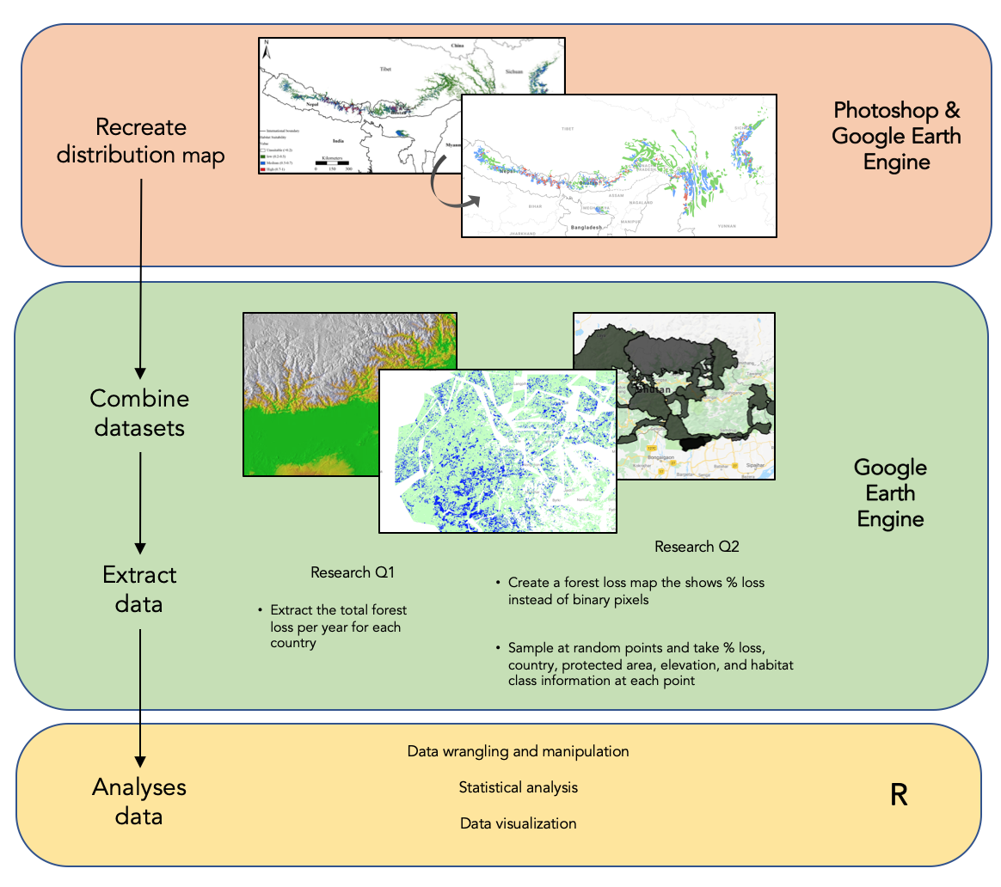2. Methods

Defining the study area

Red panda habitat was defined as any pixel with >20% canopy cover within the distribution defined by Thapa et al. This was done to better reflect red panda habitat requirements as they are predominantly found in areas with >25% canopy cover. The Thapa et al distribution was chosen as it is the most accurate and up-to-date model available. GFC data is only available from 2000 to 2018 which has defined the temporal scope of this study.

The distribution map created by Thapa et al was not available as an electronic shapefile, so I recreated the map myself. I used Photoshop to help remap the distribution map onto the base layer of google earth engine, in effect geo-referencing the image by hand using country borders as control points. Polygons were then created on GEE to represent the different habitat classes. Three habitat classes were mapped: Low 20-40%, Moderate, and High suitability. My recreation of the map will have introduced some errors and will have resulted in the miss mapping of some panda habitat. However, visual assessment of my map showed good coverage of preidicted habitat.

Data collection

Datasets

All data used in this dissertation came from pre-existing and publically available datasets (table 1). Each dataset was imported into the google earth engine and had been pre-georeferenced and porcessed. I created an image collection with all of the loaded datasets added as separate bands. To convert polygon data to an image I clipped a binary land mask to each shape, then added this to the image collection. All analysis was conducted using the native scale of the gfc dataset (~30m2).

The Hansen forest loss data was processed from Landsat imagery and classes any vegetation over 5m in height as a forest. This definition is used by me in this dissertation. Loss was only recorded if the entire pixel transitions from forest to no forest, with gain being the inverse. Forest gain was only available as a cumulative layer up to 2013. The algorithm used to process the Landsat imagery was recently updated by Hansen et al to better detect small scale forest loss from 2013 – 2018.

|  |  |  |
| --- | --- | --- |
| Dataset | Source | Description |
| Hansen V1.6 |  | The image gives a binary layer for loss no loss for 2000 – 2018 (each a separate band) and a cumulative image for the entire range. It |
| Elevation |  |  |
| WDPA |  |  |
| Country polygons |  |  |

All analysis was conducted using the native scale of the gfc dataset (~30m2).

RQ1

In order to collect the total area of forest lost for each year I grouped the yearly forest loss bands together. The area of loss pixels was calculated using the pixel area function and converted into km2. A reducer function was then used to sum the loss pixels for each year in each country. The total tree cover at the year 2000, and the amount of gain at 2013 were also extracted.

**RQ2**

I transformed the binary Hansen forest loss data into a map where each pixel represents the average forest loss within 1km2 buffer. I did this for two reasons: i) It is easier to visualise the data and see areas of high forest disturbance and ii) It provides more information on the magnitude of loss at a sample site. A mean neighbourhood circular kernel was used to convolve the image.

I created my own image collection merging the forest loss map, country data, elevation, pa coverage, and habitat class. Every data from a table was transformed into an image by clipping a land mask to its bounds.

In order to gauge the variation in forest loss within areas of interest, I used a sample based approach. 5000 random samples were taken by reducing over randPoints. This number was deemed to be the maximum number of samples without significant overlapping of sample counts, reducing double counting.

2.3 Data processing

The outputs of the earth engine scripts were export as CSV files and loaded into excel for first data cleaning. levels merged into one column and accessory and unwanted metadata for each file was removed.

in excel and then imported into R

% calculation

filtering to get rid of samples in areas less than <20% forest and in any overlapping habitat classes caused by me being a dumbass and not drawing my polygons well.

2.4 Data analysis

Statistical Models

R version alpha = 0.05

All models were planned a priori, and to have biological relevance. No model comparisons have been made as each model is designed for a specific research question. Data distributions and residual fits were visually assessed using qqplots and histograms. A linear model was used for RQ1 and nonparametric analysis was conducted for RQ2 due to the major violations of assumptions of the data (zero inflated and non-normal). Kruskal wails tests were used to compare means. This test was chosen because the distribution of forest loss values was the same shape in every group. Post hoc analysis using the kruskalmc function in pgirmess was done to identify significantly different means whilst also accounting for multiple comparisons, this is analogous to the parametric tukey HSD test.

Statistical approach. A priori model creation, biological relevance.

3. Results

What change has occurred to forests in red panda habitat?

The rate of forest loss in red panda habitat has not significantly increased across the entire range from 2000-2018 (linear model, slope = 0.0014 ± SE 0.0013, Fstatistic = 1.204, DF = 16, adjusted R2= 0.012, P = 0.288). At the country level, India and Burma were the only countries that showed a significant increase in the amount of forest lost between 2000-2018 (Table A1, Appendix). A total forest loss of 1.3% (1753 km2) was found across the entire range. 227 km2 of lost forest had regrown between 2000 - 2013.

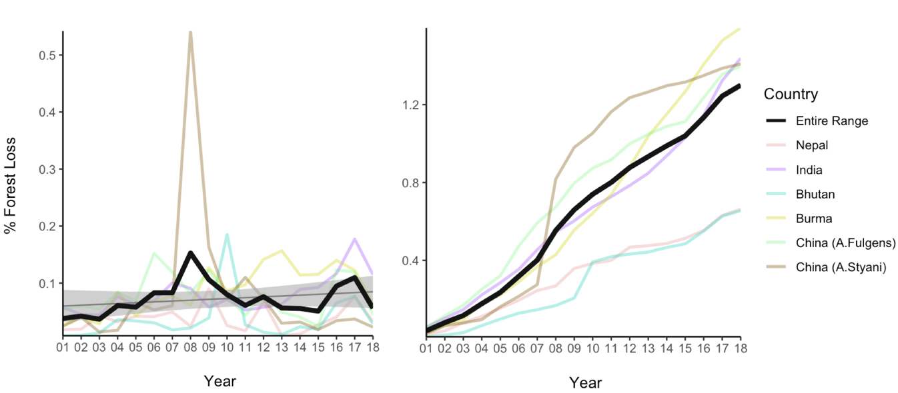

**Figure 5: Total forest cover has changed in red panda habitat from 2000 – 2018.** Left figure shows the yearly % forest loss over the study period for the entire range of the red panda, and each country. The linear model is shown as the smaller black line with the SE shown in gray B) Total area of habitat 134880 km2

Where has forest been lost in red panda habitat?

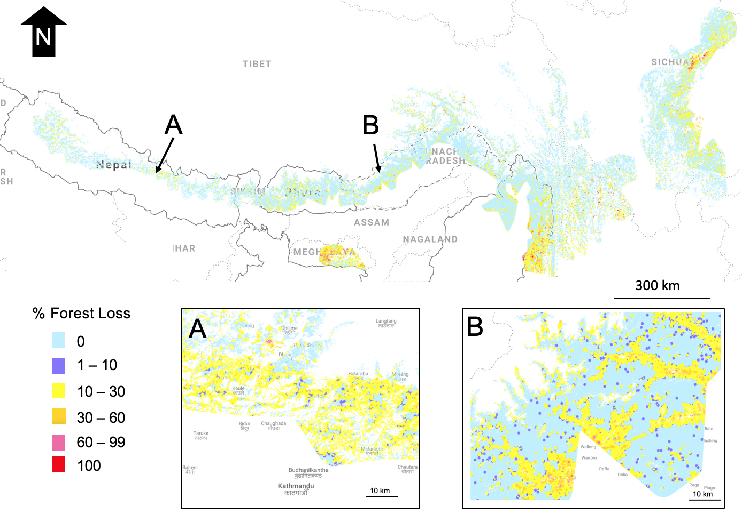Habitat loss in red panda habitat is clustered and not uniform across the range. A visual assessment of the location of loss showed that forest loss was usually found close to roads and human settlements.

**Figure 6: Map of forest loss in Red Panda habitat, with two major bottlenecks (A and B) identified.** Range wide map created with a scale of 100 m, zoom in maps A and B created at the native scale of GFC dataset (~30m).

Different proportions of forest were lost in each country (Kruskal-Wallis, χ2 = 69.256, df = 5 , p-value 1.463e-13). This is in support of H3 with china showing the highest average forest loss and Bhutan and Nepal showing lower loss.

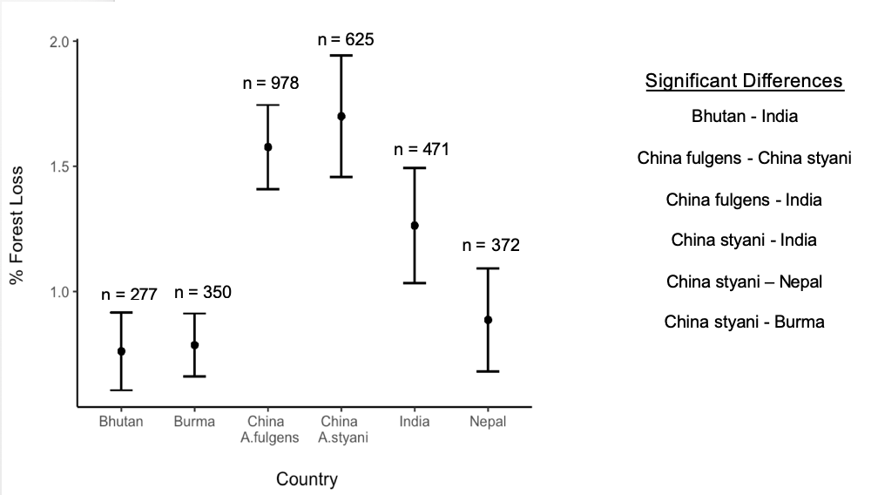

Figure 4

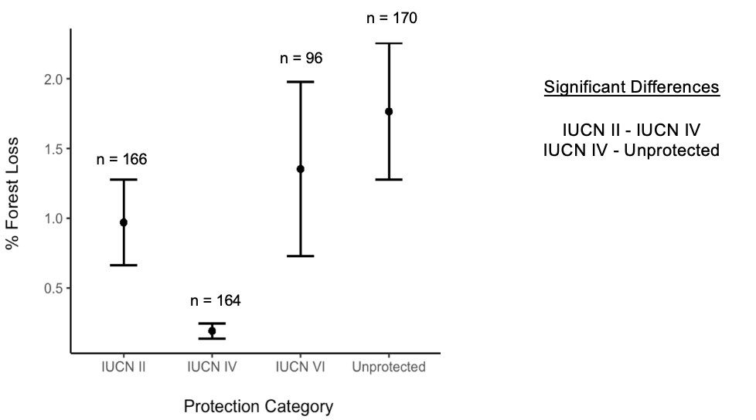Different proportions of forest were lost in areas with different protection (Kruskal-Wallis, χ2 = 16.108, df = 3, p-value 0.001078).

Figure 5

Different proportions of forest were lost in different habitat classes (Kruskal-Wallis, χ2 = 13.753, df = 2 , p-value 0.001). 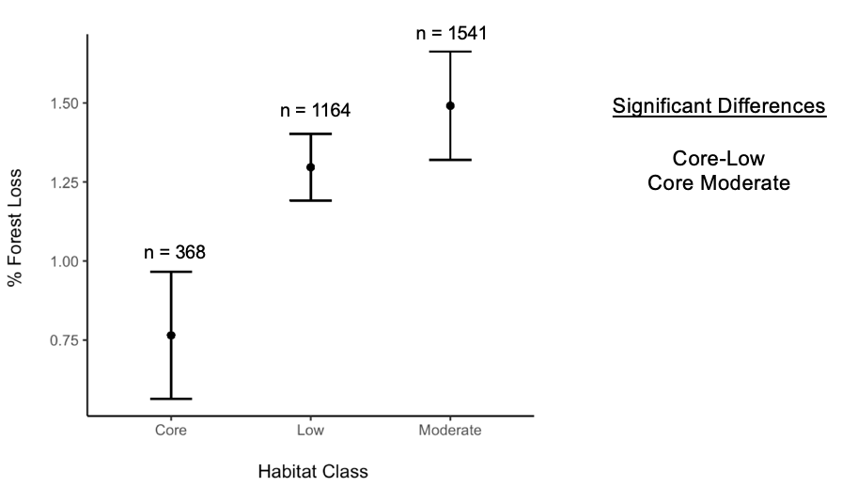

A significant relationship was found between the proportion forest loss and elevation with lower elevations (Spearman Correlation, rho = -0.1506997, n = , p-value < 2.2e-16). The probability of sampling a pixel with forest loss was also higher at lower elevation (Logistic regression, F-statistic = 80.53, Df = 3071, Adjusted R2= 0.02524, p-value = <2e-16).

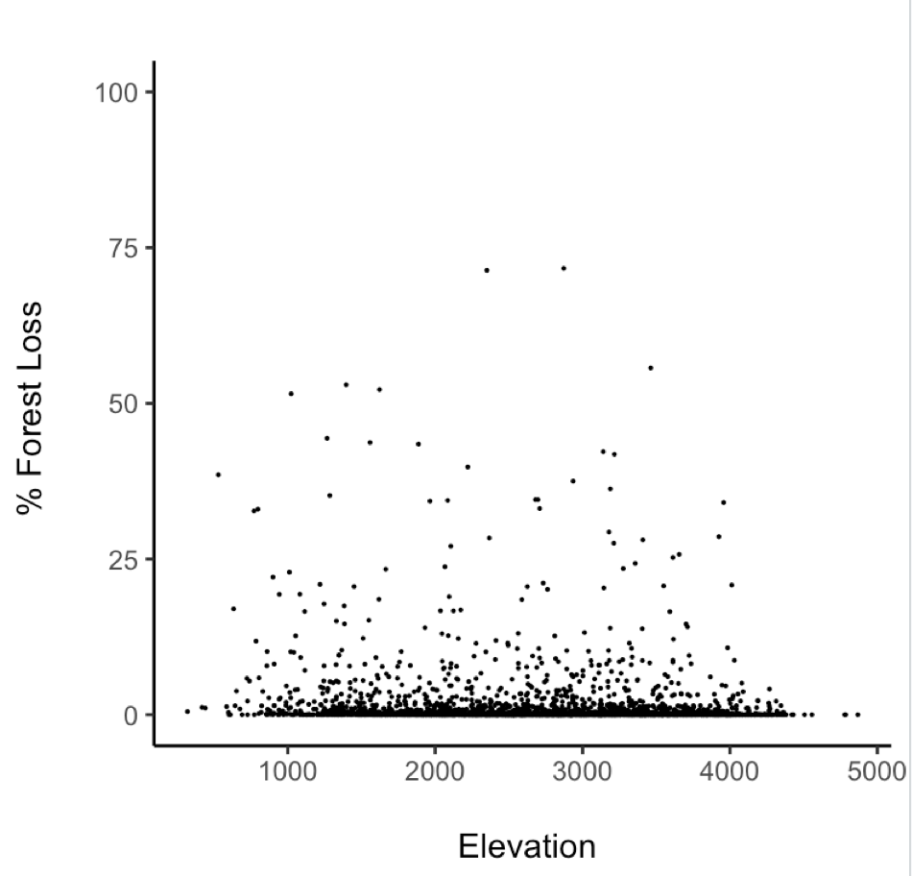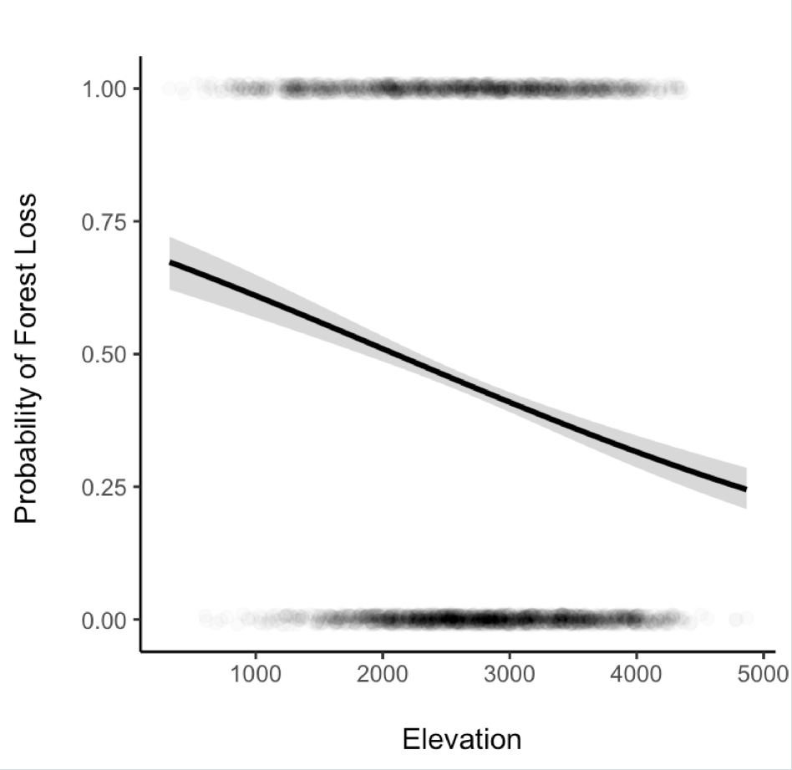

4. Discussion (Demonstrate Understanding!)

Key findings

2-4 points

Highlight what wasn’t known before

Rate of forest loss not increasing. Temporal autocorrelation is not accounted for would serve to increase rate of slope. Time means more people means more loss

4.1 How is Red Panda Habitat changing?

How do these results compare to on the ground studies?

Forest loss vs habitat degradation. Up loss by 30% +/-20%.

Similar loss in nepal vs the rest of that region.

4.2 Conservation implications

Protected areas show signs of working

Low habitat classes may act as corridor habitat, this

All habitat seems to be connected but there is loss high up the mountains too. Sympatric conservation, pool resources and identify key corridors.

4.3 Limitations

What needs to be considered when interpreting my results?

PA analysis should look at where loss is occurring. Not just absolute values as these are low.

Map may over estimate habitat as occurrence records are few and far between. Makes the forest loss analysis less specific to rps and may miss more relevant dynamics. Conducting this analysis in areas defined by local experts would produce a more panda relevant map.

IUCN classes run different in different countries

My methods only quantify loss between 2000 and 2018. Any deforestation before then is not accounted for in my analysis. Visual assessment showed that there were pre-cleared areas, particularly around settlements.

Slightly Unbalanced designs should be ok.

Due to the nature of my data, I had to rely on non-parametric tests in RQ2. Due to the large number of 0 values (no forest loss) across every group, there were many tied ranks. The standard process of averaging tied ranks was done. This resulted in a conservative estimate of significance (lowering the power) and a reduced the type 1 error rate. Kruskal Wallis test also compare the differences in the median value of groups, not the average that figures 6-9 show. If different groups have large difference in the number of tied ranks, the median values can be offset, further lowering the power of the test. A combination of these factors likely resulted in the unusual significant differences, with the apparently similar China A.fulgens and China A.styani being significantly different yet the apparently different Bhutan and China A.fulgens showing no significant difference. If I had more time I would look into models that explicitly deal with non-integer zero inflated data, potentially a quasi-poission mixed effect model or a two part hurdle model. Spatial auto correlation is an issue. I attempted to account for this my adding longitude as a random effect in a mixed model, but due to the major assumption violations, this was not possible.

4.4 Future work

What else should happen in order to design an effective range wide strategy for red pandas? Need to confirm species occurrence. Camera trapping programme

Quantify fragmentation impacts

Panda density estimates

This will work towards identifying connectivity across the range

Sympatric conservation too with Tiger conservation, Mishmi Tackin and other species of conservation concern. Large overlapping habitat.

Active remote sensing could be used key panda areas to monitor change to the structure of the vegetation and

Forest loss to gain has only been calculated for the entire range. I would explore how gain changed too.

5. Conclusion

The proportion of forest lost between 20002018 was substantially less than expected

6. References

7. Appendices

Country level breakdown of forest loss rate

India = linear model, slope = 0.004089 ± SE 0.001146, F1,16 = 12.74, P = 0.002563, DF = 16, adjusted R2= 0.4084

8. Text junk yard

The IUCN small carnivore group has identified habitat monitoring as the highest priority research topic for red pandas.